Title Of The Manuscript In ‘Title Case’ Written In ‘Times New Roman’ Font Size 14 & Bold
First Author¹, Second Author², Third Author¹, Corresponding Author¹*

Affiliation:
- Department Name, Institution Address
- Department Name, Institution Address

*Corresponding Author
Author Name :
Position :
Department :
Institution :
Email :

Preparation of Manuscript
Main Text:
Entire document has be typed in 1.5 spacing and ‘Times New Roman’ style and font size 12.
Entire document should have a margin of 2.54cm on all 4 sides.
Main Headings:
Should be in ‘Times New Roman’ font style, font size 14, Bold and Title Case.
Sub Headings:
Should be in ‘Times New Roman’ font style, font size 12, Bold and Title Case.

Referencing Style:
‘Vancouver’ referencing style is to be followed for all references. In Text references should be mentioned in Arabic Numberals in first-come-first-serve basis and the numbers should be entered in superscripted square brackets at the end of sentences like ^{[1,2]}. The references in the biobliography at the end of the document should be represented in the following format ‘Vancouver’
Journal Article:
- Kumar S. Computational identification and binding analysis of orphan human cytochrome P450 4X1 enzyme with substrates. BMC Res Notes. 2015;8(1):1–10.
- Stalin K, Ravi L, Raghavan V. Extraction, purification and structural elucidation of environmentally benign antifouling metabolite from Streptomyces thermolineatus VITKV6A. Environmental Technology & Innovation. 2022;25:102096.

Figures & Tables
All figures and tables should be numbered sequentially, and should appear in the main text where they are discussed. Figures should be of high quality (minimum 300dpi). All figures and tables should have a self-explanatory legend. Figure’s legend should be below the figure, while table’s legend should be above the table.

Plagiarism Report
Manuscripts will be accepted only if the plagiarism content is less than 12%.

Abstract
Abstract should be written in ‘Times New Roman’ with font size 12 and should contain word count of 150 to 250 words. Highlight the key findings and significance of this study. What are the key methods incorporated in this study. What does the study conclude and what are its future prospects.

Keywords: Erysiphe necator, Homology modeling, Protein drug targets, PMDB, AutoDock.
(Separate each key word with coma)

Introduction
Grape is one of the most important economical and commercial fruit for the world and it is a major contribution to the country’s GDP (Gross domestic product) and it is a wide adaptability crop ^{[1,2]}. Vitis vinifera is a dicotyledonous and annual crop plant species that is a member of the Vitaceae family, commonly called "grape" and "draksha"^{[3]}, it's cultivated in temperate, sub-tropical, tropical regions, all over the world ^{[1,3,4]}. Global production of grape is estimated to 67 million metric tons per annum at present. China is one of the leading country in the production of grape with 8,651.83 thousand tons, followed by Italy (7,787.83 thousand tons), the united states of America (6,777.73 thousand tons), Spain (6,107.20 thousand tons), France, Turkey, Argentina, chile, and south Africa^{[1]}. India occupies the eighteenth position in world for production of grape and it's cultivated in an area of 111.4 thousand hectares with a production of 1,234.9 thousand tons ^{[1]}. Almost 71% of global grape production is used for wine, 27% fresh fruit, 2% dried fruit ^{[3]}.

Materials & Methods
Isolation Of Bacteria
The soil sample is serially diluted upto 10⁻⁴ dilutions and the diluted sample is loaded on to a freshly prepared nutrient agar plate. The cultured plates are then incubated at 37°C for 24hrs and then observed for colony growth ^{[4]}.

Extraction Of Phytochemicals
Dried plant leaf samples are grounded well using mortar and pestle and the phytochemicals are extracted using maceration technique for 48hrs. The mixture of solvents and plant sample are mixed in magnetic stirrer for 48hrs and then the solvent is separated using filtration via Whatmann No.1 filter paper. The filtered solvents are then dried to obtain crude extract of the phytochemicals ^{[5]}.
Results And Discussion
Ramachandran Plot Analysis
The ramachandran plot analysis was performed for all protein model structures constructed in SWISSModel tool. The protein models that demonstrated more than 90% of residues in the favored regions of the ramachandran plot were considered to be reliable for structural applications. All 66 proteins demonstrated above 90% of the residues within the favored regions in the ramachandran plot and hence were considered for further processing. Graphical representation of ramachandran plot analysis of a preferred protein model with 100% of residues in favored region and a least preferred model with 82% of residues within the favored region are shown in Figure.1.

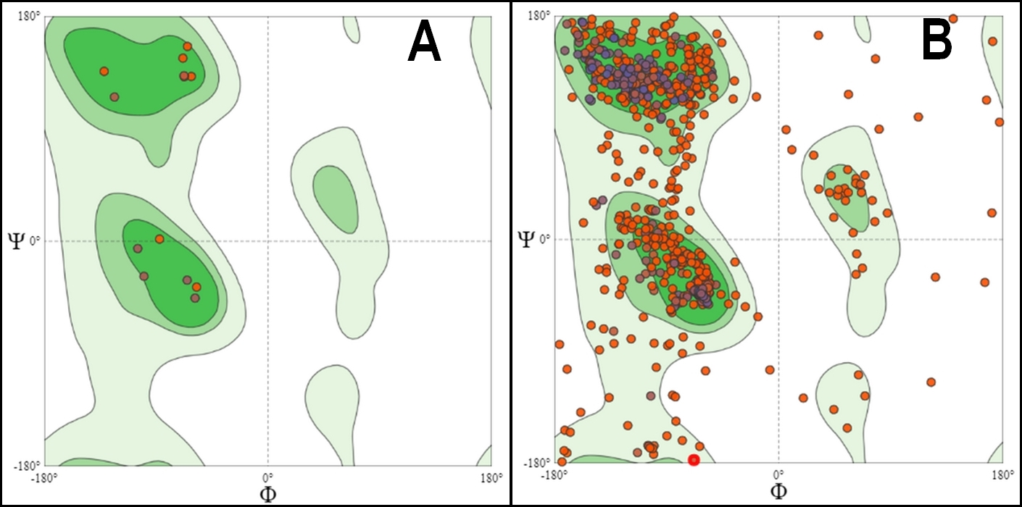
Figure.1: Ramchandran plot protein analysis of constructed protein models. A: Preferred model with 100% residues in favored region; B: Least preferred model with 82% residues in the favored region.

PMDB ID submission
All 66 protein model structures that were verified using ramachandran plot were then submitted to PMDB (Protein Model Data Base: srv00.recas.ba.infn.it › PMDB) website. The protein model structures were submitted to public database for easy access to researchers to further applications of the same. The list of constructed protein models that were submitted to PMDB is tabulated in Table.1.

Table.1: Modeled protein structure submissions to PMDB
Sl.No. | Drug target name | UniProt ID | PMDB ID
1 | ATP-dependent DNA helicase PIF1 | A0A0B1PEI0 | PM0082721
2 | Adenylyltransferase and sulfurtransferase uba4 | A0A0B1P610 | PM0082722
3 | Phosphatidylserine decarboxylase proenzyme 2 | A0A0B1P526 | PM0082728
4 | Putative myosin class v myosin | A0A0B1P6S1 | PM0082816
5 | ATP-dependent 6-phosphofructokinase | A0A0B1PDE5 | PM0082731
6 | NADPH--cytochrome P450 reductase | A0A0B1P387 | PM0082732
7 | Proliferating cell nuclear antigen | A0A0B1NZA1 | PM0082733
8 | Adenylate kinase | A0A0B1P0M5 | PM0082735
9 | GTP:AMP Phosphotransferase | A0A0B1PEI1 | PM0082736
10 | Glutathione reductase | A0A0B1P915 | PM0082738

Conclusion
The current study aimed at construction of 3D computational protein model structures of a un explored fungal pathogen Erysiphe necator that causes powdery mildew disease, which causes a great economical impact in grapewine crop cultivation. Further to demonstrate the SBCADD application of the constructed protein models, protein-ligand docking analysis was carried between two known antifungal drugs and their drug targets. Among the two test antifungal agents, tebuconazole was found to be a better effective antibiotic that could possibly help control the infection of this pathogen in grape cultivation. However, further in-silico validation and in-vitro studies are required for confirmation.

Acknowledgement:
The authors thank the institution for supporting this research work.

Conflict Of Interest
No known conflict of interest.

Funding Source
No funding was availed for this work.

References:
1. Shinde PV. An Economics of Grapes under Horticulture in India. Int J Res Sci Innov. 2016;3(2):69–71.
2. Sharma D, Rani R, Chaturvedi M, Yadav JP. Antibacterial Capacity and Identification of Bioactive Compounds By Gcms of Allium Cepa. Int J Pharm Pharm Sci. 2018;10(2):116.
3. Kumar S, Sandhir R, Ojha S. Evaluation of antioxidant activity and total phenol in different varieties of Lantana camara leaves. BMC Res Notes. 2014;7(1):1–9.

